

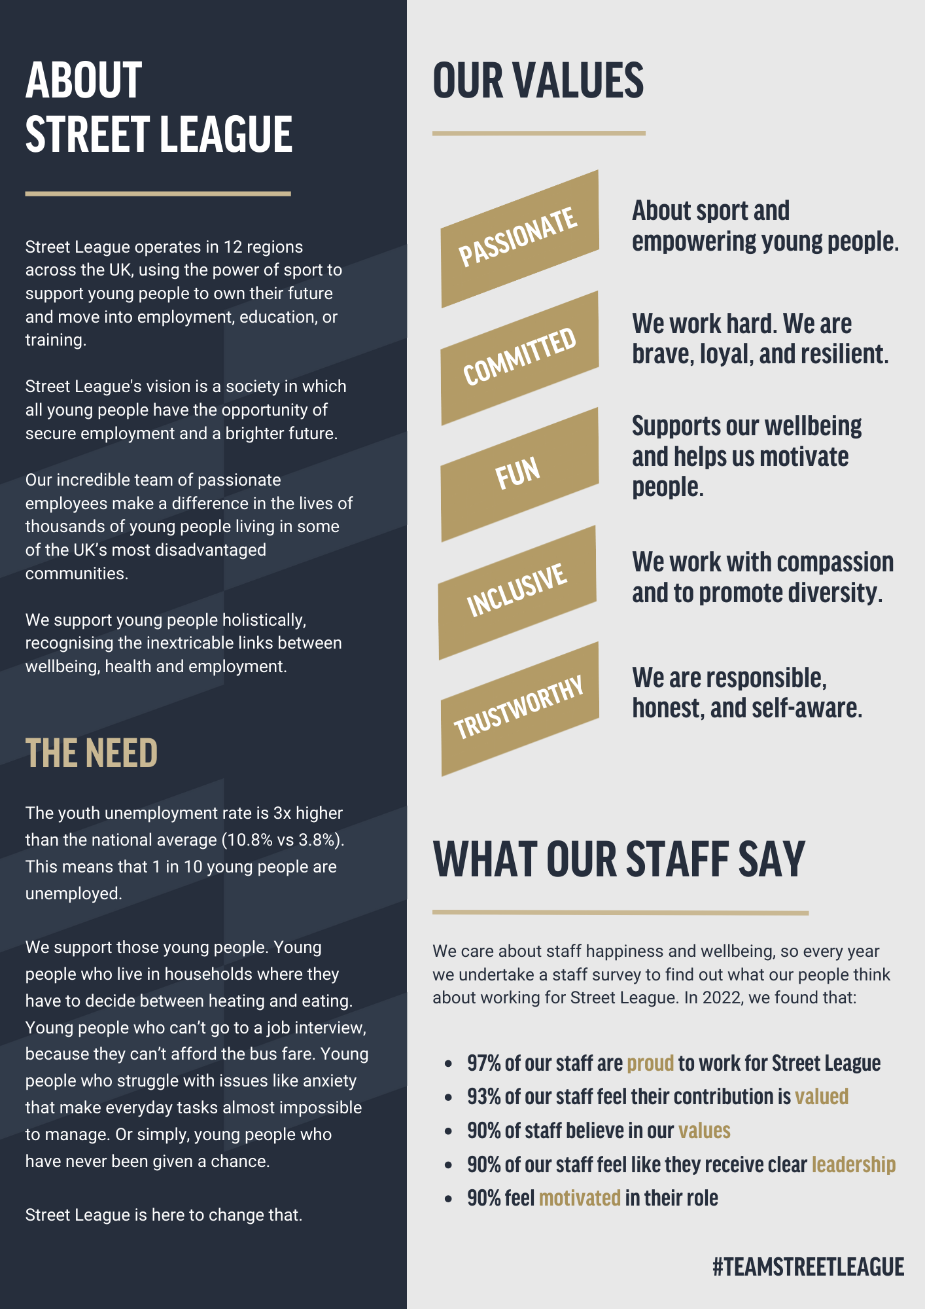
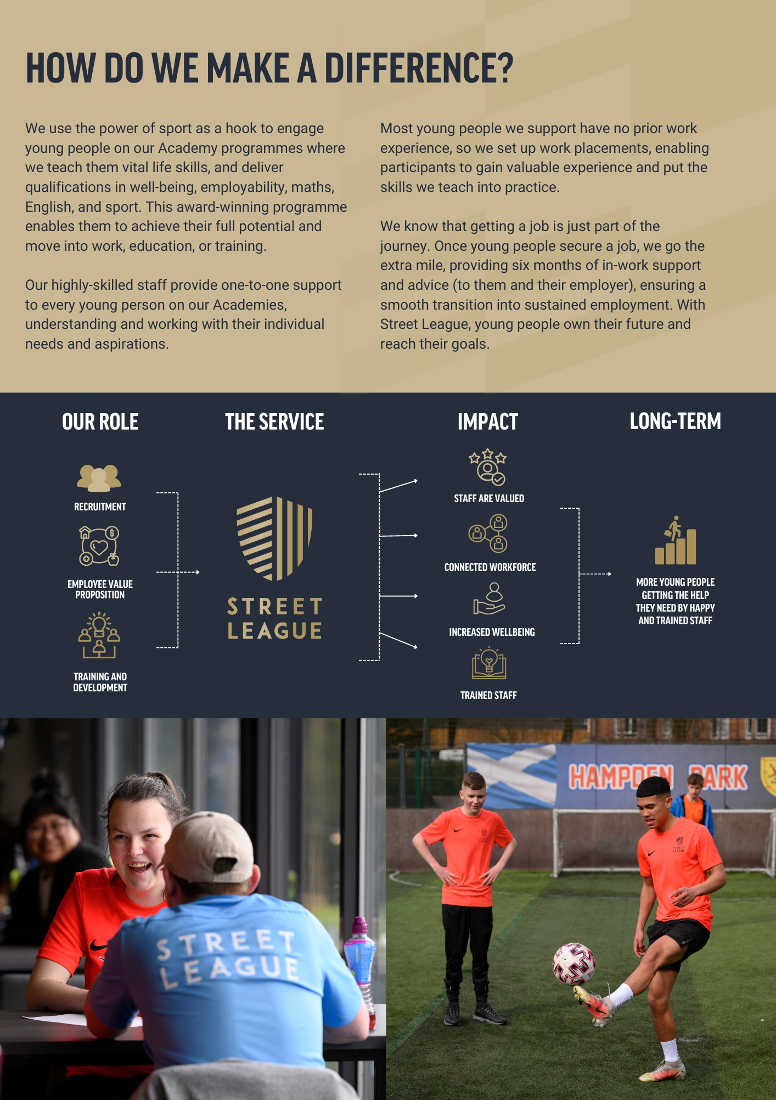

Job Description

POST TITLE - Director of Operations
RESPONSIBLE TO - Chief Executive Officer (CEO)
RESPONSIBLE FOR - Head of Operations x 2, Head of Employer Engagement x 1

GRADE - Senior Management Team

Role Summary

The Director of Operations is responsible for providing strategic leadership of Street League's UK operational function, ensuring that the organisation delivers outstanding impact for young people through high-performing, innovative and sustainable services.

As a member of the Senior Management Team, the Director of Operations is accountable for developing and delivering the operational strategy that supports Street League's Business Plan, organisational growth and long-term sustainability. The role will lead operational transformation, service design, workforce capability and performance improvement across all programmes and regions.

Working closely with the Chief Executive Officer and fellow Directors, the Director of Operations will ensure that operational delivery remains commercially competitive, evidence-led and aligned with national policy, commissioner priorities and the evolving needs of young people.

The Director provides strategic leadership to Heads of Operations, creating an environment where operational excellence, innovation, accountability and continuous improvement drive exceptional outcomes for young people, partners and funders.

The role will also oversee the Head of Employer Engagement to build, maintain, and grow relationships with employers and corporate partners that translate into meaningful opportunities, sustainable engagement, and measurable impact for young people and communities.

Major Duties and Responsibilities

Strategic Leadership:

- Develop and implement Street League's UK Operational Strategy in line with the organisational Business Plan and strategic priorities.

- Lead the continual evolution of Street League's operating model to ensure services remain innovative, sustainable and responsive to the needs of young people, commissioners and partners.

- Provide strategic leadership across all operational activity, ensuring consistency of delivery and quality across England and Scotland.

- Drive organisational transformation programmes that improve operational effectiveness, efficiency and impact.

- Ensure operational planning aligns with financial sustainability, organisational growth and contractual obligations.

- Lead the development of annual operational business plans and organisational priorities.

- Work collaboratively with the CEO and Directors to contribute to corporate strategy, organisational development and future planning.

- Represent Operations at Board, Committee and Executive meetings, providing strategic reports, recommendations and assurance.

Leadership Responsibilities:
- Provide strategic leadership, coaching and support to the Heads of Operations
- Foster a culture of high performance, accountability, innovation and continuous improvement.
- Lead workforce planning to ensure operational structures remain effective and scalable.
- Ensure operational teams are equipped through effective learning, development and change management.
- Lead cross-functional collaboration across Operations, Contracts and Quality, Commercial, HR, Finance, Marketing and Data teams.
- Promote Street League's values and behaviours across all operational activity.
- Undertake any additional duties appropriate to the role as requested by the Chief Executive Officer.

Role-Specific Responsibilities:
Operations Performance
- Hold overall accountability for operational performance across all Street League programmes and contracts.
- Establish and monitor organisational performance frameworks that drive excellence in delivery, quality, financial performance and social impact.
- Ensure operational targets are achieved through effective performance management of Heads of Operations.
- Monitor national performance trends and implement strategic interventions where necessary.
- Ensure consistency in delivery standards across all operational regions.

Product Development and Innovation
- Lead the strategic development and continuous improvement of Street League's products, programmes and delivery models.
- Ensure programmes remain evidence-led, outcome-focused and aligned to labour market trends and commissioner priorities.
- Oversee innovation projects that improve participant outcomes, operational efficiency and organisational impact.
- Work collaboratively with Contracts and Commercial teams to develop operational solutions that strengthen funding opportunities.

Commercial Growth
- Support the Commercial Director and Director of Contracts and Quality in developing competitive operational models for tenders and funding opportunities.
- Assess operational capacity and delivery feasibility for new contracts and partnerships.
- Contribute to organisational growth through service innovation and operational planning.

Governance, Risk and Compliance
- Chair or Co-Chair organisational Safeguarding and Health & Safety Forums.
- Provide Executive oversight of safeguarding, health and safety and operational compliance
across the organisation.
- Ensure operational risks are effectively identified, managed and reported.
- Lead business continuity planning for operational services.
- Ensure compliance with statutory, contractual and regulatory requirements.

Performance, Quality and Continuous Improvement
- Develop organisational quality assurance frameworks that promote consistency and excellence.
- Champion data-driven decision making through effective operational reporting and analysis.
- Embed a culture of continuous improvement through performance review, evaluation and learning.
- Work with the Data and Contracts teams to ensure accurate reporting, compliance and performance monitoring.
- Hold strategic oversight of operational budgets and resource allocation.
- Monitor operational financial performance and ensure value for money across all programmes.
- Contribute to organisational financial planning and forecasting.
- Support long-term financial sustainability through effective operational management.
- Co-chair Employee and EDI Forums
- Oversee and embed youth voice and impactful feedback via the Youth Board implementation UK wide
- Oversee and attendance at OPM Forum in conjunction with Heads of Operations.

Employer Partnerships
- Own the overall Employer and Partnerships strategy, translating organisational plans into a clear partnership and employer engagement plan.
- Set the strategic direction and priorities for employer partnerships across the UK.
- Identify and lead strategic growth opportunities, including new markets, sectors, geographic opportunities and partnership models.
- Own the senior-level relationship strategy for the organisation's most significant employment partnerships.

External Relationships
- Build and maintain strategic relationships with commissioners, partners, employers, funders and national stakeholders.
- Represent Street League externally at strategic forums, conferences and partnership meetings.
- Promote Street League as a sector-leading organisation within employability, education and youth development.

Person Specification
Knowledge and Understanding | - Excellent understanding of the employability, education and skills landscape across the UK.  - Strong knowledge of commissioning, public sector procurement and outcome-based contracts.  - Excellent understanding of the challenges facing young people and the policy environment.  - Knowledge of organisational development, change management and continuous improvement methodologies.  - Knowledge of governance, safeguarding, health and safety and risk management.  - Degree level qualification or equivalent professional experience (essential).  - Relevant leadership or management qualification (desirable).
Skills and Abilities | - Strategic leadership and organisational planning.  - Executive-level communication, influencing and negotiation skills.  - Financial planning, budget management and commercial awareness.  - Ability to lead organisational change and transformation.  - Strong analytical and decision-making capability using operational data and insight.  - Excellent stakeholder management and partnership development skills.  - Ability to lead and inspire geographically dispersed teams.  - Excellent report writing, presentation and governance skills.
Experience | - Significant senior leadership experience within multi-site operations.  - Leading large operational teams through senior managers.  - Delivering organisational strategy and operational transformation.  - Managing performance within contract-based and outcome-driven environments.  - Developing new services, products and operational models.  - Managing significant operational budgets.  - Working with Boards, Executive Teams and senior stakeholders  - Experience within the employability, education, youth or third sector (desirable).
Behaviours | - Passionate about Street League's vision of supporting young people.  - Strategic and forward thinking.  - Collaborative and inclusive.  - Innovative and solutions focused.  - Resilient and accountable.  - Commercially aware.  - Inspirational leader with integrity.  - Calm and decisive under pressure.
Values | We are:  - Committed - We work hard. We are brave, loyal, and resilient.  - Fun - Supports our wellbeing and helps us motivate people.  - Inclusive - We work as a team with compassion and to promote diversity.  - Passionate - About sport and empowering young people.  - Trustworthy - We are responsible, honest, and self-aware.

STREET LEAGUE BENEFITS, REWARD AND RECOGNITION PROVISIONS

The information below provides a summary of the benefit, reward and recognition schemes available. Please check your contract of employment, company policies and scheme rules for eligibility and terms and conditions of provisions. Street League reserves the right to withdraw, amend the scheme and change providers as appropriate.

 | Benefit | Provider | What is it
Lifestyle and Protection | Pension Scheme |  | Eligible Street League employees are enrolled in a pension plan after three months of employment and both company and employee contribute 4% of basic salary.
Lifestyle and Protection | Critical Illness Cover |  | Critical Illness cover provides you with a tax-free lump sum payment if you or your children suffer a covered critical illness.
Lifestyle and Protection | Employee Assistance Programme |  | Access to a 24/7 confidential helpline and online information, as well as counselling sessions via help@hand EAP.
Lifestyle and Protection | Life Insurance |  | 2 x base salary cover after one year of service with the company. Additional coverage provided for senior staff.
Lifestyle and Protection | Leave Entitlement |  | 37 days leave per year (inclusive of public holidays), plus one additional day awarded for each year of service up to a maximum of 3 additional days  We also offer 1 additional day of religious leave to accommodate employees who need time off to observe their faith.
Lifestyle and Protection | Mintago |  | Mintago’s simple and comprehensive approach to financial wellbeing is designed for people of all demographics and employees can rest assured that their financial worries, questions and needs can be addressed and supported.  Highlights include Financial Advisors, Grocery Salary Sacrifice (saving basic rate taxpayers 8% on their grocery costs), Retirement Planner, Pension Hunter and Money Helper – AI.
Lifestyle and Protection | Cash Health Plan |  | Employees with over a year of service have basic health coverage through Simply Health, with dependent children covered at no extra cost.
Lifestyle and Protection | Enhanced Sick absence pay |  | Company paid sickness absence in accordance with the sickness absence policy and contract of employment.
Lifestyle and Protection | Season Ticket Loan |  | Interest free loan to cover the cost of your season ticket, repaid from your salary payments.
Lifestyle and Protection | Enhanced Jury Service |  | Full salary paid during Jury service minus deduction for expenses received from the court
Lifestyle and Protection | Cycle to work |  | Purchase of a bicycle and/or safety equipment to get to work, tax free and paid for monthly via salary sacrifice up to the value of £1000.
 | Anti-Harassment Help Line |  | Tell Jane provide a confidential service for complaints.
 | Pregnancy Support & Advice |  | Pregnant employees and managers have access to information on managing pregnancy, maternity leave, and return to work.

Other | Staff Equipment | All employees receive the necessary equipment, such as laptops, phones, and branded Street League kit, to carry out their job responsibilities.
Other | Staff Survey & Forums | We are committed to hearing and promoting staff voice. Have your say in the annual anonymous staff survey or join our staff forum and/or EDI forum.
Other | Training & Development | Opportunities to gain skills and receive formal training, participate in working groups (such as curriculum development, quality forums, etc) and undertake CPD.

